## Last Name: Nguyen

**First Name: Quoc**

**Student Id. Number: H290130**

**Answer:**

**Answer:**

**Answer:**

**Answer:**

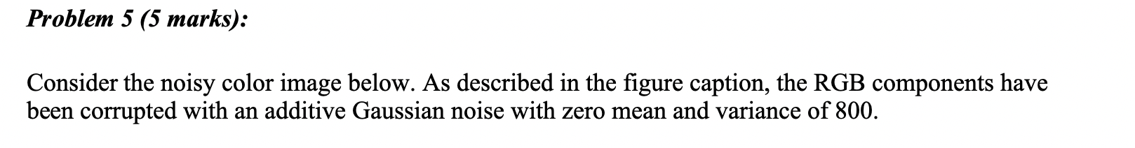

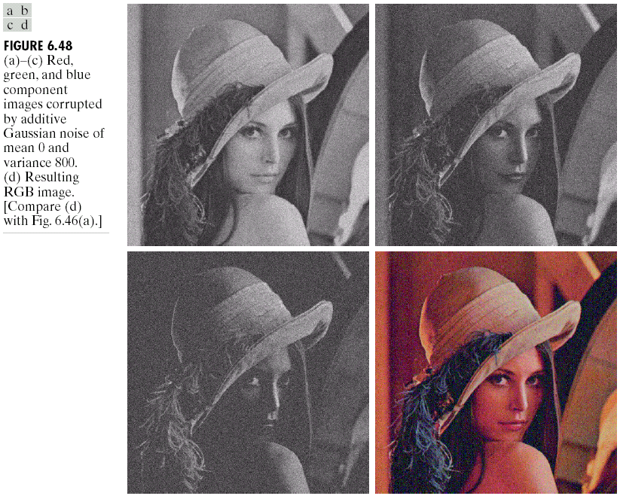

**Answer:**

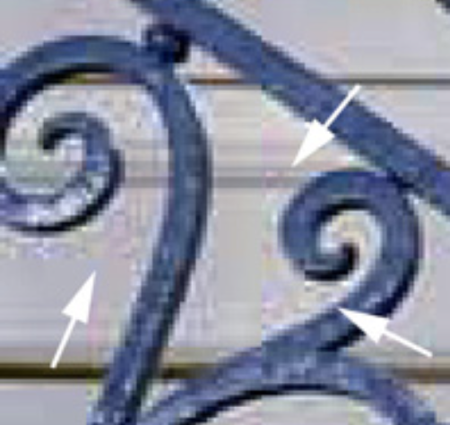

**Answer:**